**Moai Calibration test**

These are the steps in the order which you will do:

1. Power On
2. Galvo Scanning Test
3. Leveling

Please do not pour resin into vat until the instruction tell you so or it will make testing more difficult.

-

Moai is shipped with galvos and Plate calibrated.

To make sure everything is still working after delivery, we will run three tests:

DO NOT INSTALL BUILD PLATE OR PUT ANY RESIN INTO VAT for calibration test

1. Power on Check  
     
   Click the Power Switch on the Front Panel to Turn on the Machine (pic)  
   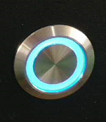  
   Two things to look for here:  
   - Z Axis is raised to the top of the rod before stopping  
   - The Plate will perform a tilt action and resume to level position  
     
   You should see this screen when Moai is ready:  
     
   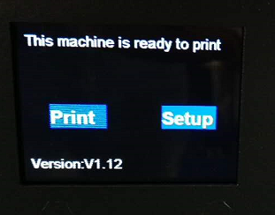
2. Setting check  
   Use the Control Knob above the Power Switch to move between “Print” and “Setup”

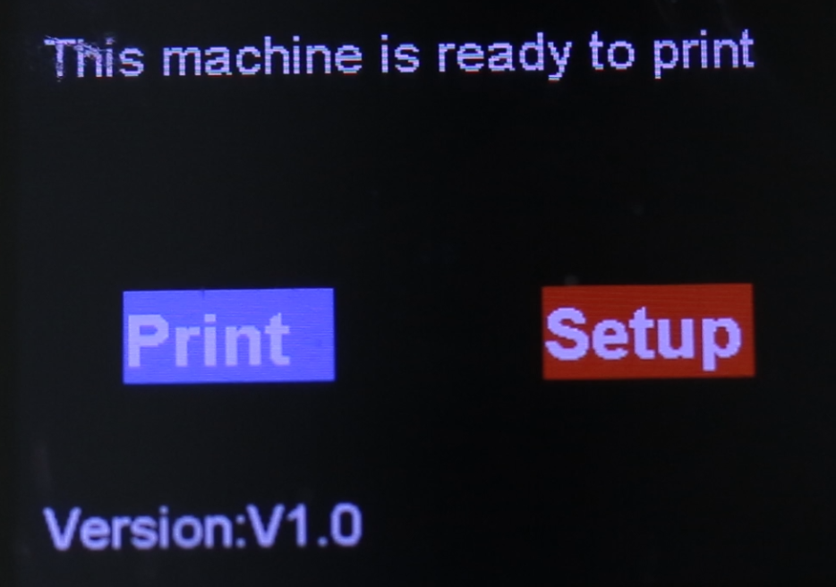  
Press the knob to enter “Setup” (Double press to go back)  
  
Please check your setting and adjust to match:

If not, you can select and click on each entry to adjust the value to match above numbers  
  
Then please use Control Knob to scroll down to advanced_setting

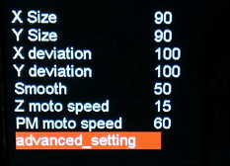  
  
Check your setting against:  
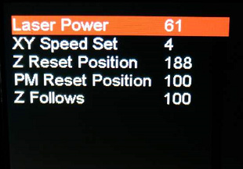  
  
  
  
Laser power is a key setting. We like to set it around 61% for Moai’s resin. Please check against that. Non-Moai resin may have lower or higher laser power need.

1. Galvo test

Please download following files

Circle marking: <https://drive.google.com/open?id=0Bzke6lBHG_z5MkhwQjZ0bk5UaXM>

Circle test Gcode: <https://drive.google.com/open?id=0Bzke6lBHG_z5NmdFUmZENDZ0OEk>

Circle market is a PDF file called: calibration-circle.pdf

Print it out and cut the square with circle out. Place it in the Vat

*note: for US/Canada user please ensure that the Calibration Circle PDF prints at 100% scale, not 91% because of the A4 to US Letter conversion. The dimensions of the printed box should be 5-1/8" (130.18mm), not 4-11/16" (119.06mm).

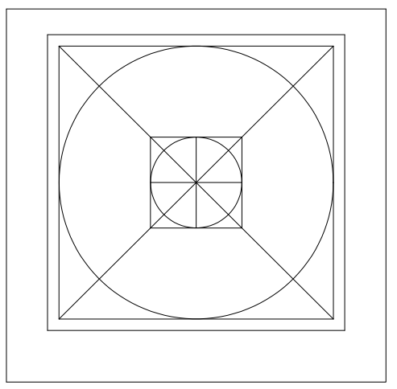

Extract P_yuan-test.gcode from P_yuan-test.zip and place the GCode file in directory called “gcode” in a SD card.

Insert the SD Card in the Machine:

(reshoot)

Insert the vat with the printed calibration-circle (pic)

Select Print from the Moai’s menu and Click Confirmed.

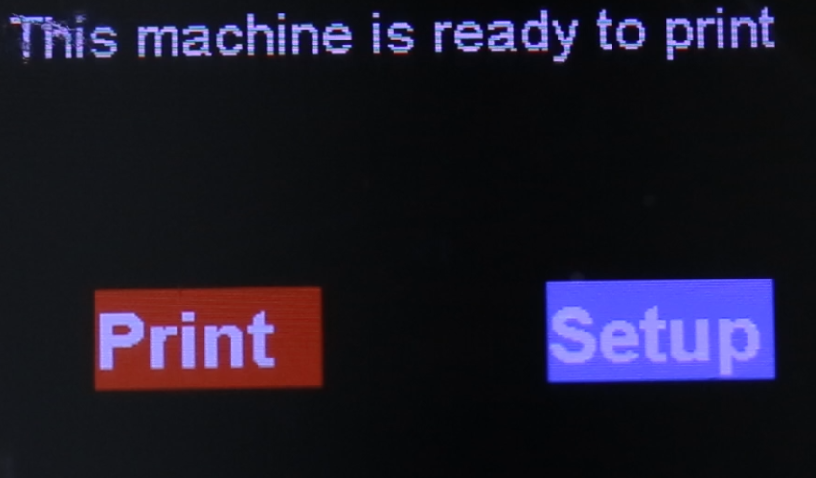

You should see Z-Axis drops the Build Plate arm, tilt the Vat and begin to scan like below

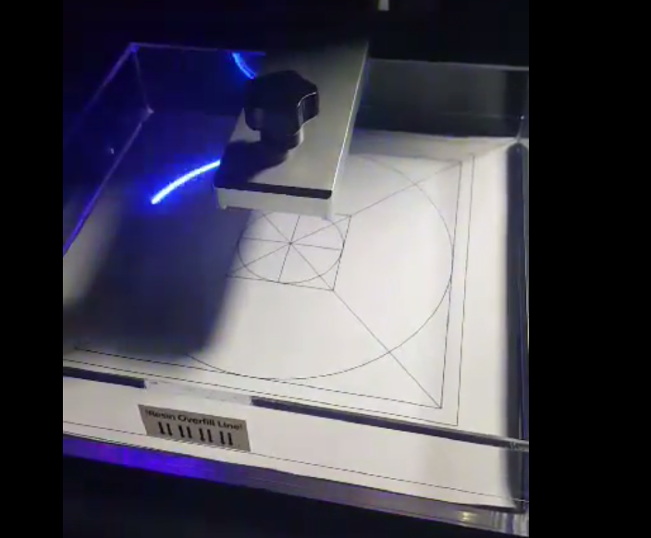

Video: <https://youtu.be/4jeJfWrDAyI>

Move the paper slightly such that the circle overlaps with the laser scanning path

-

**Leveling**

Since there are slight variation in plate and vat, it is important to level before doing any print with resin. You should do leveling when you are changing vat

Folowing instruction is for firmware 1.14 or later. If you are not on firmware 1.14 yet, please upgrade first use firmware upgrade instruction here

<https://peopoly.dozuki.com/Guide/Moai+-+Firmware+Upgrade/3>

Leveling for Moai is very easy to do, please follow these steps:

1. Connect the power cable before turning it on
2. Install VAT (make sure push all the way in, Do NOT pour resin)
3. Install Built Plate (Make sure the knob on top is tighten)
4. Turn Moai on
5. Use the knob to turn. Press the knob to select “Setup”

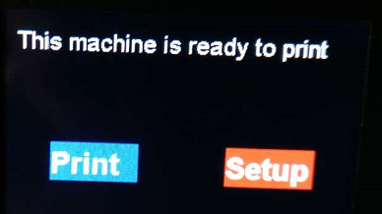

1. Go to the advanced_setting

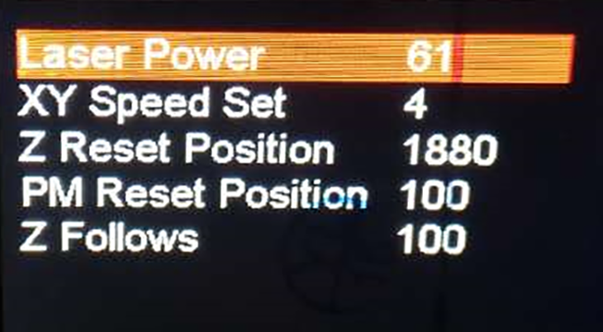

1. Change the **Z Reset Position to 1880**. Double press on the knob to exit menu. If it is already at 1880, turn to 1879 and then turn back to 1880 before double press. At this point **the build Plate should began descending** If there is any loud noise or Plate is going too low such it is hitting and keep press vat, press the power button off. Otherwise, just let it descent to print position.



**It is very important that during step 7 that the build plate is lower into the vat before going to the next step**

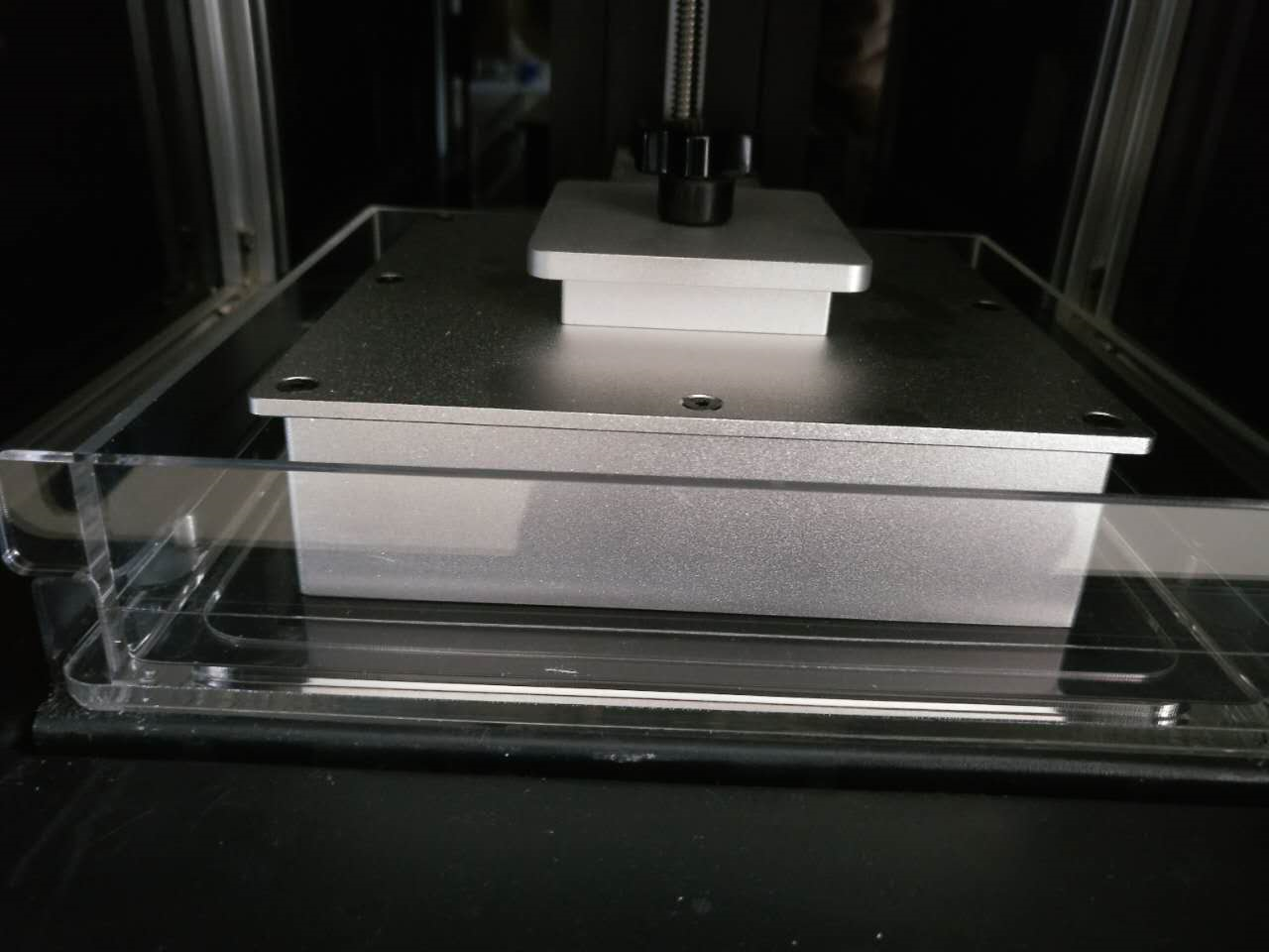

8. This is the key part of leveling:

There are 4 nuts/bolts right underneath of the VAT, and they look like this

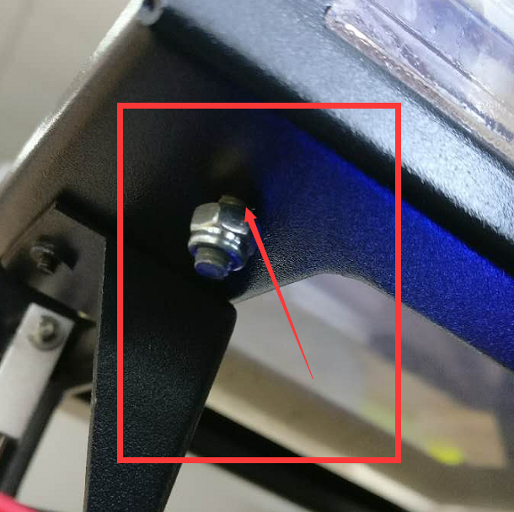

First, loose all four of them to a point that the nut to a point where you can see there is a gap between the nut and platform.(see above picture)

This is the tool to turn the nut when working:

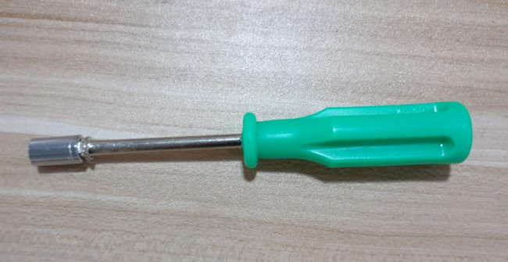

Then, tighten those nuts such that there is **NO** gap between nut and frame (nut just touching frame) but not press against it.(see below picture)

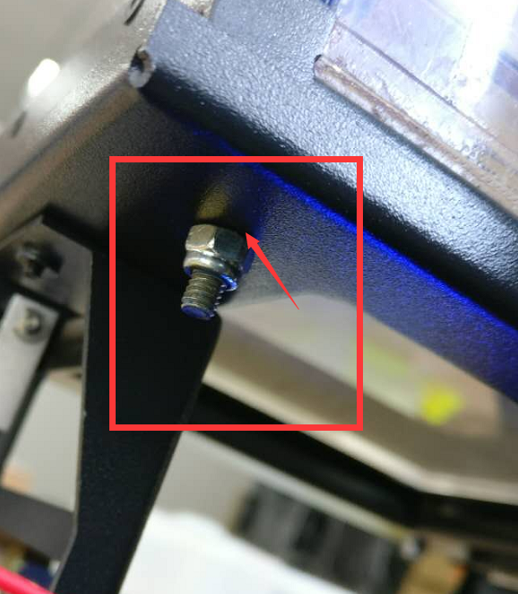

You can use a piece of paper to check the gap. If you can not slide the paper between the nut and the platform. It is good.

-

Once you are done.

Power Off the Moai by pressing power buttom

The power on Moai again

Go to Advanced settings and change Z-Reset Position from 1880 to 1877



Double press and the plate will drop down. Your Moai is now leveled.

**Power Off Moai before going to next step**

Leveling video: <https://www.youtube.com/watch?v=652Kjil-sk8>

(*need update)

-

For micro adjustments in case you need it:

Tightening the nut lowers the vat.

Loosening the nut raises the vat.

-

**Test Print**

* Download this test file:

<https://drive.google.com/open?id=0Bzke6lBHG_z5ajN6VU1scll6QTQ>

* Extract PM2_zring-test.gcode from the zip file



* Insert the included SD card into your computer

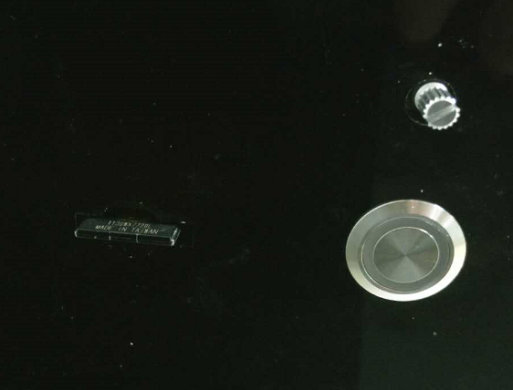

* Create a directory called “gcode” in the SD card
* Copy PM2_zring-test.gcode to the gcode directory created in last step
* Eject the SD card and insert it into Moai’s SD card reader
* Select Print from the Moai menu using the control knob
* Select gcode directory
* Select PM2_zring-test.gcode , and confirm to start printing

This print should last about 20 minutes and print at the B corner, see below:

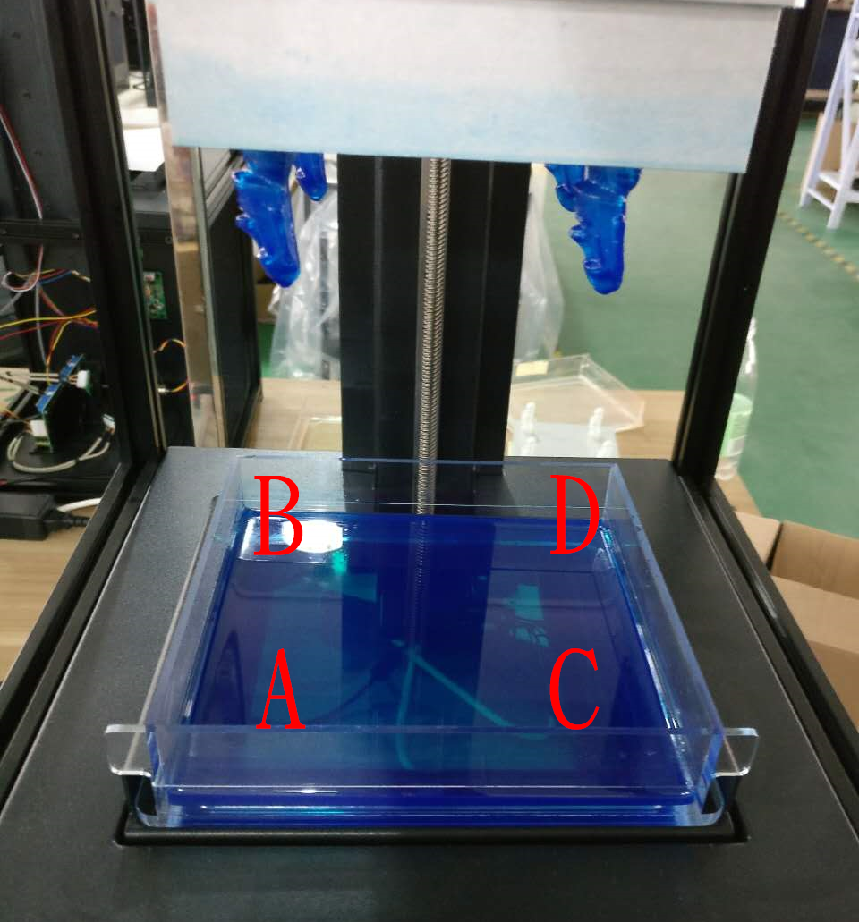

Couple scenarios can happy:

1. Print is successfully, print sticks to the plate and looks like the ring:

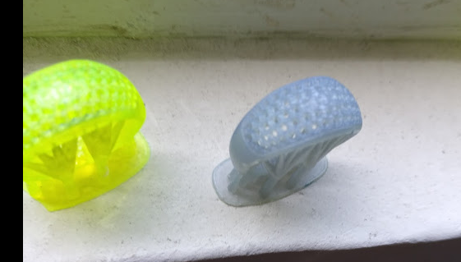

1. Nothing is on the plate, a flattened piece can be found at the bottom of vat at the B spot
2. A partial ring is printed and seems to broken off from the middle
3. A ring is print it but seemed to have a side of it getting cut off
4. Congrats
5. There are couple possibilities:

Check setting to make sure laser energy is at 61 and xy print speed is at 4

Test print. If it is doesn’t work. Please redo leveling and make sure you follow the steps. If rest position at 188, ½ turn tightening doesn’t work for you, then do leveling at 188 but without any tightening

1. Please increase laser energy to 62 and see if that works
2. Please check to see if any cables blocking laser